NOTE: BRING YOUR OWN DISTRIBUTION TABLES FOR HYPOTHESIS TESTING

Define Hypothesis with an example?
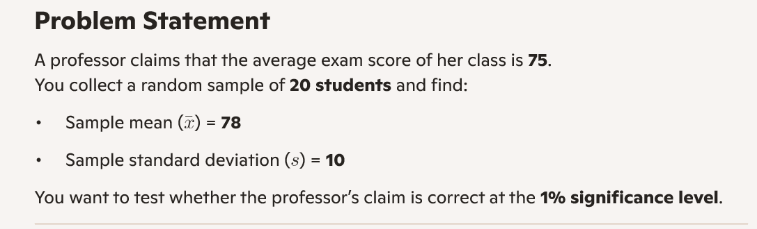

A vendor claims that average weight of box is 1.84 kg. Customer randomly choose 64 parts and finds the sample weight has 1.88 kg. Suppose population standard deviation is 0.3 kg. Use significance level 5
% . test the hypothesis that True-Mean is 1.84kg

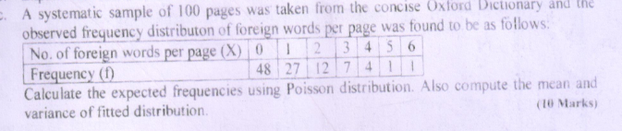

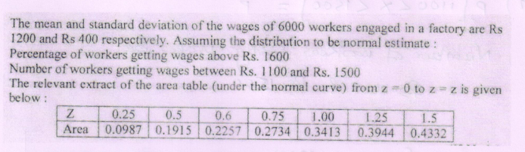

The data on prices (Rs in per kg) of a certain commodity during 2000 to 2004 are shown below:
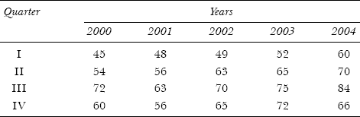
Compute the seasonal indexes by the average percentage method

Write the objectives of studying time-series analysis and variations in time series analysis?
Define Smoothing Methods? Name them?
Define Hypothesis with an example?
Explain components of Time Series?
Define time series analysis? Mention the methods?
Explain the flow of Hypothesis Testing with diagram?

The following table relates to the tourist arrivals (in millions) during 2010 to 2016 in India: Fit a straight line trend by the method of least squares and estimate the number of tourists that would arrive in the year 2020.
Year | 2010 | 2011 | 2012 | 2013 | 2014 | 2015 | 2016
Tourist Arrivals | 18 | 20 | 23 | 25 | 24 | 28 | 30

Calculate the Three and Five year Moving average for the following time series (compulsory)

Year | 2013 | 2014 | 2015 | 2016 | 2017 | 2018 | 2019 | 2020 | 2021 | 2022 | 2023
Production | 500 | 540 | 550 | 530 | 520 | 560 | 600 | 640 | 620 | 610 | 640

